

Lab Experiment – 11
Map Coloring using CSP

Aim
To implement the Map Coloring problem using a Constraint Satisfaction Problem (CSP) in Python.

Objective
To assign different colors to the regions of a map such that no two adjacent regions have the same color.

Algorithm
- Define the regions and their neighboring regions.
- Define the available colors.
- Select an uncolored region.
- Assign a color to the selected region.
- Check whether the color assignment satisfies all constraints.
- If the assignment is valid, move to the next region.
- If no valid color is available, backtrack to the previous region.
- Continue until all regions are colored.
- Display the solution.

FlowChart


Code
colors = ['Red', 'Green', 'Blue']

regions = ['A', 'B', 'C', 'D']

neighbors = {
'A': ['B', 'C'],
'B': ['A', 'C', 'D'],
'C': ['A', 'B', 'D'],
'D': ['B', 'C']
}

assignment = {}

def is_valid(region, color):
for neighbor in neighbors[region]:
if neighbor in assignment and assignment[neighbor] == color:
return False
return True

def solve():
if len(assignment) == len(regions):
return True

# Select an uncolored region
for region in regions:
if region not in assignment:
break

# Try each available color
for color in colors:
if is_valid(region, color):
assignment[region] = color

if solve():
return True

# Backtrack
del assignment[region]

return False

if solve():
print("Map Coloring Solution:")
for region in regions:
print(region, "->", assignment[region])
else:
print("No solution exists")

Output
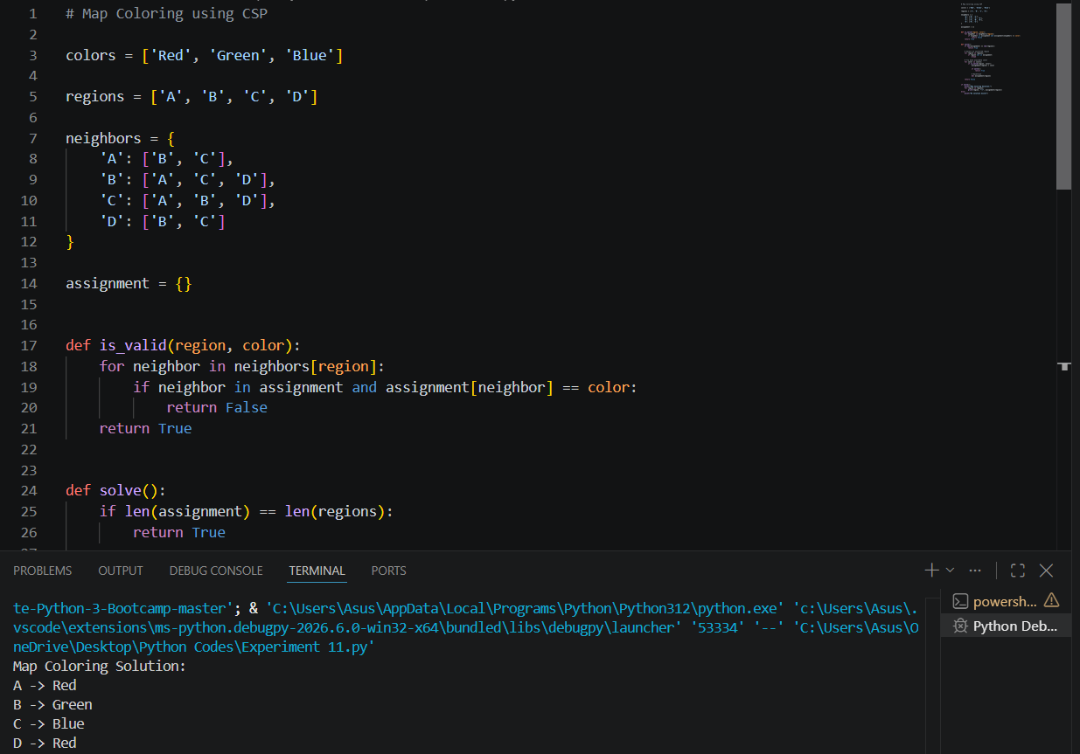

Result
The Map Coloring problem was successfully implemented using the Constraint Satisfaction Problem (CSP) approach.

Conclusion

The CSP-based program successfully assigns colors to all regions while satisfying the constraint that adjacent regions must have different colors. Backtracking is used whenever a color assignment violates a constraint.

